4B OS LAB-02 ASSIGNMENT

## **Muhammad Danish cs182019**

**Question1**:

**CODE**:

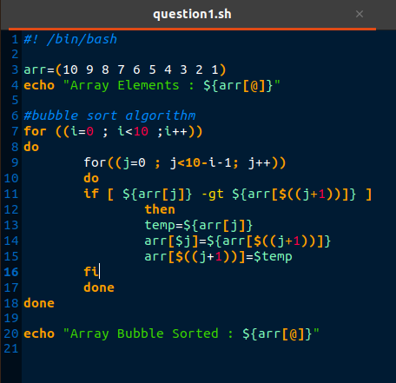

**OUTPUT**:

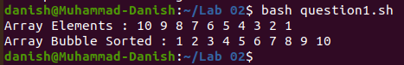

**Question2**:

**CODE**:

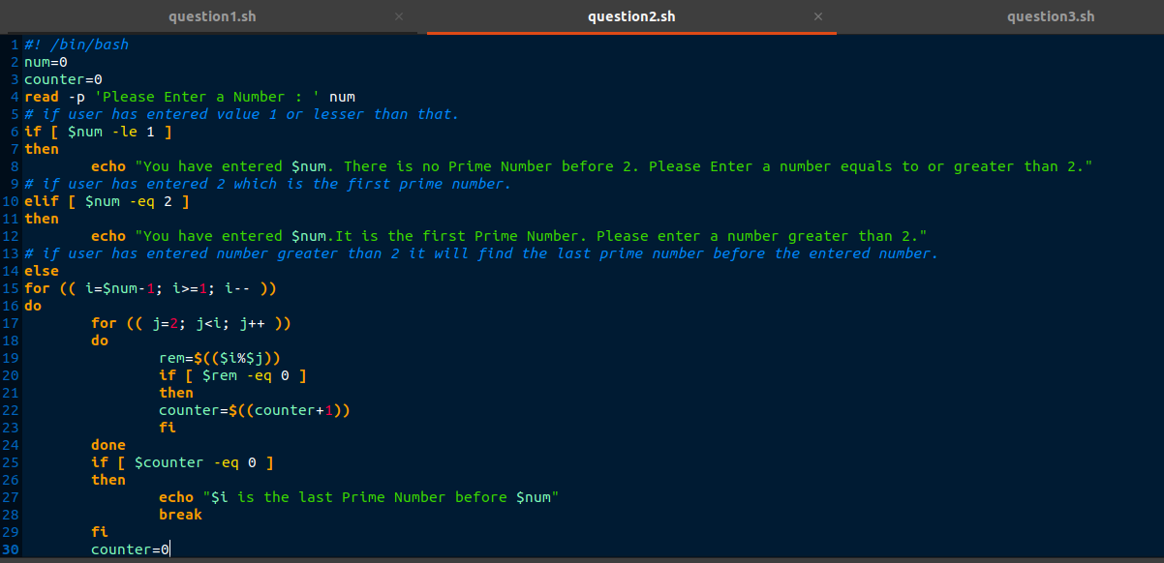



**OUTPUT**:

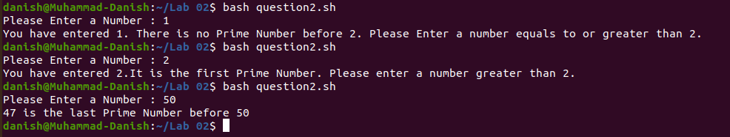

**Question3**:

**CODE**:

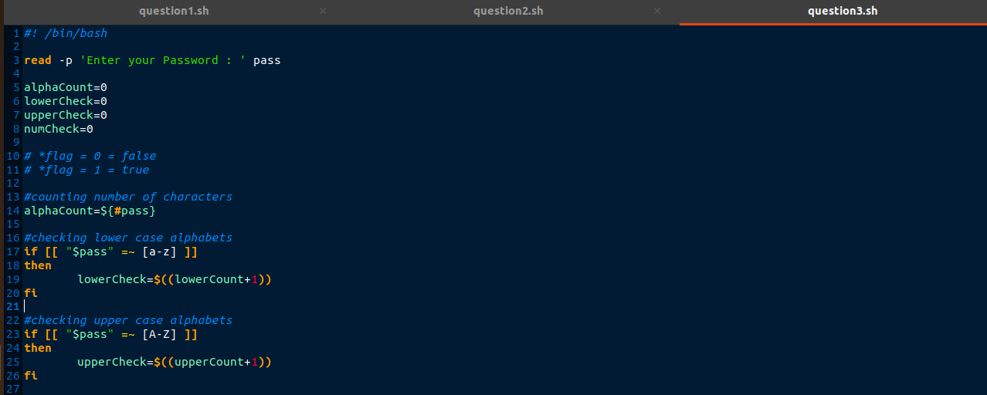

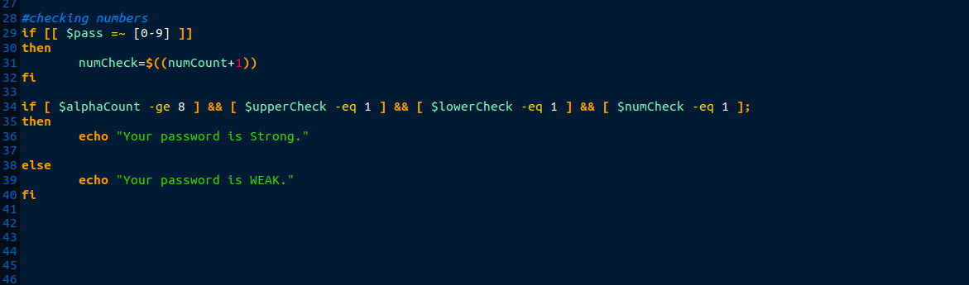

**OUTPUT**:

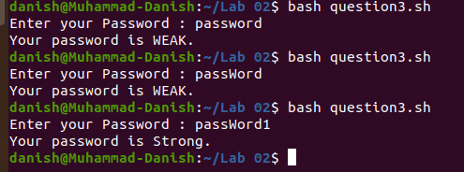

**Muhammad Danish  
cs182019**